**CHƯƠNG 5:**

***Bài 1:***

1. **T1**=B’C

**T2**=A’B

**T3**=A+B’C

**T4**=A’B D=A’BD’+(A’B)’D=A’BD’+(A+B’)D=A’BD’+AD+B’D



**F1**=T3+T4= A+B’C+ A’BD’+AD+B’D

=A(1+D)+B’C+A’BD’+B’D

=(A+A’BD’)+B’C+B’D

=(A+A’)(A+BD’)+B’C+B’D

=A+BD’+B’C+B’D

**F2**=A’B+D’

1. **T1**=AB’CD+AB’CD’+A’B’CD+A’B’CD’

**T2**=A’BCD+A’BCD’+A’BC’D+A’BC’D’

**T3**=ABCD+ABCD’+ABC’D+ABC’D’+AB’C’D+AB’C’D’+AB’CD+AB’CD’+A’B’CD+ A’B’CD’

**T4**=A’BCD’+A’BC’D’+ABCD+ABC’D+AB’CD+AB’C’D+A’B’CD+A’B’C’D

**F1**=ABCD+ABCD’+ABC’D+ABC’D’+AB’CD’+AB’C’D+AB’C’D’+AB’CD+ AB’CD’+ A’B’CD+A’B’CD’+AB’CD+A’B’C’D+ABCD’+ABC’D’+A’BCD’+A’BC’D’

**F2**=A’BCD+A’BCD’+A’BC’D+A’BC’D’+ABCD’+ABC’D’+AB’CD’+AB’C’D’+A’BC’D’ +A’B’CD’+A’B’C’D’

|  |  |  |  |  |  |  |  |  |  |
| --- | --- | --- | --- | --- | --- | --- | --- | --- | --- |
| A | B | C | D | T1 | T2 | T3 | T4 | F1 | F2 |
| 0 | 0 | 0 | 0 | 0 | 0 | 0 | 0 | 0 | 1 |
| 0 | 0 | 0 | 1 | 0 | 0 | 0 | 1 | 1 | 0 |
| 0 | 0 | 1 | 0 | 1 | 0 | 1 | 0 | 1 | 1 |
| 0 | 0 | 1 | 1 | 1 | 0 | 1 | 1 | 1 | 0 |
| 0 | 1 | 0 | 0 | 0 | 1 | 0 | 1 | 1 | 1 |
| 0 | 1 | 0 | 1 | 0 | 1 | 0 | 0 | 0 | 1 |
| 0 | 1 | 1 | 0 | 0 | 1 | 0 | 1 | 1 | 1 |
| 0 | 1 | 1 | 1 | 0 | 1 | 0 | 0 | 0 | 1 |
| 1 | 0 | 0 | 0 | 0 | 0 | 1 | 0 | 1 | 1 |
| 1 | 0 | 0 | 1 | 0 | 0 | 1 | 1 | 1 | 0 |
| 1 | 0 | 1 | 0 | 1 | 0 | 1 | 0 | 1 | 1 |
| 1 | 0 | 1 | 1 | 1 | 0 | 1 | 1 | 1 | 0 |
| 1 | 1 | 0 | 0 | 0 | 0 | 1 | 0 | 1 | 1 |
| 1 | 1 | 0 | 1 | 0 | 0 | 1 | 1 | 1 | 0 |
| 1 | 1 | 1 | 0 | 0 | 0 | 1 | 0 | 1 | 1 |
| 1 | 1 | 1 | 1 | 0 | 0 | 1 | 1 | 1 | 0 |

|  |  |  |  |  |
| --- | --- | --- | --- | --- |
| AB  CD | 00 | 01 | 11 | 10 |
| 00 |  |  |  |  |
| 01 |  |  |  |  |
| 11 | 1 |  |  | 1 |
| 10 | 1 |  |  | 1 |

T1=B’C

T2=A’B

|  |  |  |  |  |
| --- | --- | --- | --- | --- |
| AB  CD | 00 | 01 | 11 | 10 |
| 00 |  | 1 |  |  |
| 01 |  | 1 |  |  |
| 11 |  | 1 |  |  |
| 10 |  | 1 |  |  |

T3=A+B’C

|  |  |  |  |  |
| --- | --- | --- | --- | --- |
| AB  CD | 00 | 01 | 11 | 10 |
| 00 |  |  | 1 | 1 |
| 01 |  |  | 1 | 1 |
| 11 | 1 |  | 1 | 1 |
| 10 | 1 |  | 1 | 1 |

T4=AD+B’D+A’BD’

|  |  |  |  |  |
| --- | --- | --- | --- | --- |
| AB  CD | 00 | 01 | 11 | 10 |
| 00 |  | 1 |  |  |
| 01 | 1 |  | 1 | 1 |
| 11 | 1 |  | 1 | 1 |
| 10 |  | 1 |  |  |

F1=A+B’D+B’C+A’BD’

|  |  |  |  |  |
| --- | --- | --- | --- | --- |
| AB  CD | 00 | 01 | 11 | 10 |
| 00 |  | 1 | 1 | 1 |
| 01 | 1 |  | 1 | 1 |
| 11 | 1 |  | 1 | 1 |
| 10 | 1 | 1 | 1 | 1 |



F2=D’+A’B

|  |  |  |  |  |
| --- | --- | --- | --- | --- |
| AB  CD | 00 | 01 | 11 | 10 |
| 00 | 1 | 1 | 1 | 1 |
| 01 |  | 1 |  |  |
| 11 |  | 1 |  |  |
| 10 | 1 | 1 | 1 | 1 |

***Bài 2:***

1. F=[(A’D)’.A’]’.(A’+BC)

=[(A+D’).A’]’.(A’+BC)

=(A’D+A).(A’+BC)=A’D+A’BCD+ABC=A’D(1+BC)+ABC=A’D+ABC

G=(A’+BC).(A’D)’=(A’+BC).(A+D’)=A’D’+ABC+BCD’

=A’D’+BC(A+D’)=A’D’+BC(A+D’)(A+A’)(D+D’)=A’D’+BC(A+A’D’)

=A’D’+ABC+A’BCD’=A’D’+ABC

3. Thiết kế mạch với 3 input và 1 output

1. Output là 1 khi giá trị của input nhỏ hơn 3. Ngược lại thì 0
2. Output là 1 khi giá trị của input là số chẵn.

a).

Đặt 3 input lần lượt là X,Y,Z và output là Q

Truth table:

|  |  |  |  |
| --- | --- | --- | --- |
| X | Y | Z | Q |
| 0 | 0 | 0 | 1 |
| 0 | 0 | 1 | 1 |
| 0 | 1 | 0 | 1 |
| 0 | 1 | 1 | 0 |
| 1 | 0 | 0 | 0 |
| 1 | 0 | 1 | 0 |
| 1 | 1 | 0 | 0 |
| 1 | 1 | 1 | 0 |

* Q = X’.Y’.Z’+X’.Y’.Z+X’.Y.Z’

Dựa vào Bìa Karnaugh => Q= X’.Y’+X’.Z’

Circuit:

b).

Đặt 3 input lần lượt là X,Y,Z và output là P

|  |  |  |  |
| --- | --- | --- | --- |
| X | Y | Z | P |
| 0 | 0 | 0 | 1 |
| 0 | 0 | 1 | 0 |
| 0 | 1 | 0 | 1 |
| 0 | 1 | 1 | 0 |
| 1 | 0 | 0 | 1 |
| 1 | 0 | 1 | 0 |
| 1 | 1 | 0 | 1 |
| 1 | 1 | 1 | 0 |

Dựa vào Bìa Karnaugh => P= Z’

Circuit:

4. Thiết kế mạch với 3 inputs x,y,z và 3 outputs A,B,C.Khi input tính theo hệ nhị phân là 0,1,2, hoặc 3 thì output theo hệ nhị phân lớn hơn input. Khi input theo hệ nhị phân 4,5,6 hoặc 7 thì output theo hệ nhị phân nhỏ hơn input.

Truth table :

|  |  |  |  |  |  |
| --- | --- | --- | --- | --- | --- |
| x | y | z | A | B | C |
| 0 | 0 | 0 | 0 | 0 | 1 |
| 0 | 0 | 1 | 0 | 1 | 0 |
| 0 | 1 | 0 | 0 | 1 | 1 |
| 0 | 1 | 1 | 1 | 0 | 0 |
| 1 | 0 | 0 | 0 | 1 | 1 |
| 1 | 0 | 1 | 1 | 0 | 0 |
| 1 | 1 | 0 | 1 | 0 | 1 |
| 1 | 1 | 1 | 1 | 1 | 0 |

Với A , ta có K-map:

|  |  |  |  |  |
| --- | --- | --- | --- | --- |
| z xy | 00 | 01 | 11 | 10 |
| 0 | 0 | 0 | 1 | 0 |
| 1 | 0 | 1 | 1 | 1 |

=>A=xy+yz+xz

Với B:

|  |  |  |  |  |
| --- | --- | --- | --- | --- |
| z xy | 00 | 01 | 11 | 10 |
| 0 | 0 | 1 | 0 | 1 |
| 1 | 1 | 0 | 1 | 0 |

=>B=xyz

Với C:

|  |  |  |  |  |
| --- | --- | --- | --- | --- |
| z xy | 00 | 01 | 11 | 10 |
| 0 | 1 | 1 | 1 | 1 |
| 1 | 0 | 0 | 0 | 0 |

=>C=z’

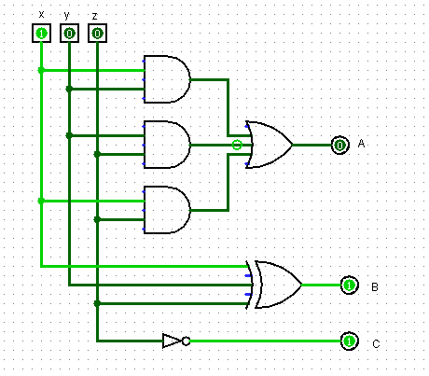

1. A Majority

Thiết kế mạch Majority bằng bảng chân trị, biểu thức, biểu đồ logic

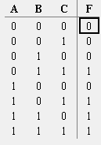

F = B C + A C + A B

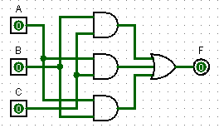

1. Thiết kế mạch mà mạch đó chuyển 4 bit trong mã Gray sang 4 bit trong số nhị phân

Vẽ mạch trên với cổng exclusive-or

|  |  |  |  |  |  |  |  |  |
| --- | --- | --- | --- | --- | --- | --- | --- | --- |
| A | B | C | D | X | Y | Z | T |  |
| 0 | 0 | 0 | 0 | 0 | 0 | 0 | 0 | 0 |
| 0 | 0 | 0 | 1 | 0 | 0 | 0 | 1 | 1 |
| 0 | 0 | 1 | 1 | 0 | 0 | 1 | 0 | 2 |
| 0 | 0 | 1 | 0 | 0 | 0 | 1 | 1 | 3 |
| 0 | 1 | 1 | 0 | 0 | 1 | 0 | 0 | 4 |
| 0 | 1 | 1 | 1 | 0 | 1 | 0 | 1 | 5 |
| 0 | 1 | 0 | 1 | 0 | 1 | 1 | 0 | 6 |
| 0 | 1 | 0 | 0 | 0 | 1 | 1 | 1 | 7 |
| 1 | 1 | 0 | 0 | 1 | 0 | 0 | 0 | 8 |
| 1 | 1 | 0 | 1 | 1 | 0 | 0 | 1 | 9 |
| 1 | 1 | 1 | 1 | 1 | 0 | 1 | 0 | 10 |
| 1 | 1 | 1 | 0 | 1 | 0 | 1 | 1 | 11 |
| 1 | 0 | 1 | 0 | 1 | 1 | 0 | 0 | 12 |
| 1 | 0 | 1 | 1 | 1 | 1 | 0 | 1 | 13 |
| 1 | 0 | 0 | 1 | 1 | 1 | 1 | 0 | 14 |
| 1 | 0 | 0 | 0 | 1 | 1 | 1 | 1 | 15 |

K – map X:

|  |  |  |  |  |
| --- | --- | --- | --- | --- |
| CD  AB | 00 | 01 | 11 | 10 |
| 00 |  |  |  |  |
| 01 |  |  |  |  |
| 11 | 1 | 1 | 1 | 1 |
| 10 | 1 | 1 | 1 | 1 |

* X = A

K map Y:

|  |  |  |  |  |
| --- | --- | --- | --- | --- |
| CD  AB | 00 | 01 | 11 | 10 |
| 00 |  |  |  |  |
| 01 | 1 | 1 | 1 | 1 |
| 11 |  |  |  |  |
| 10 | 1 | 1 | 1 | 1 |

* Y = A’B + AB’ = AB

K map Z:

|  |  |  |  |  |
| --- | --- | --- | --- | --- |
| CD  AB | 00 | 01 | 11 | 10 |
| 00 |  |  | 1 | 1 |
| 01 | 1 | 1 |  |  |
| 11 |  |  | 1 | 1 |
| 10 | 1 | 1 |  |  |

* Z = A’BC’ + A’B’C + ABC ++ AB’C’

= A’(BC’ + B’C) + A(BC + B’C’)

= A’(B+ A(B)’

= A = x

|  |  |  |  |  |
| --- | --- | --- | --- | --- |
| CD  AB | 00 | 01 | 11 | 10 |
| 00 |  | 1 |  | 1 |
| 01 | 1 |  | 1 |  |
| 11 |  | 1 |  | 1 |
| 10 | 1 |  | 1 |  |

T = A

= y

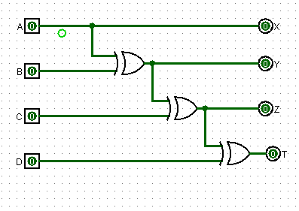

**7.**

|  |  |
| --- | --- |
| **ABCD** | **WXYZ** |
| **0000** | **0000** |
| **0001** | **1111** |
| **0010** | **1110** |
| **0011** | **1101** |
| **0100** | **1100** |
| **0101** | **1011** |
| **0110** | **1001** |
| **0111** | **1000** |
| **1000** | **1000** |
| **1001** | **0111** |
| **1010** | **0110** |
| **1011** | **0101** |
| **1100** | **0100** |
| **1101** | **0011** |
| **1110** | **0010** |
| **1111** | **0001** |

|  |  |  |  |  |
| --- | --- | --- | --- | --- |
| **CD**  **AB** | **00** | **01** | **11** | **10** |
| **00** |  | **1** | **1** | **1** |
| **01** | **1** | **1** | **1** | **1** |
| **11** |  |  |  |  |
| **10** | **1** |  |  |  |

|  |  |  |  |  |
| --- | --- | --- | --- | --- |
| **CD**  **AB** | **00** | **01** | **11** | **10** |
| **00** |  | **1** | **1** | **1** |
| **01** | **1** |  |  |  |
| **11** | **1** |  |  |  |
| **10** |  | **1** | **1** | **1** |

W **=** A'(B + C + D) + AB'C'D'

x = B'(C + D) + CB'D'

= B ⊕ (C + D)

= A ⊕ (B + C + D)

|  |  |  |  |  |
| --- | --- | --- | --- | --- |
| **CD**  **AB** | **00** | **01** | **11** | **10** |
| **00** |  | **1** |  | **1** |
| **01** |  | **1** |  | **1** |
| **11** |  | **1** |  | **1** |
| **10** |  | **1** |  | **1** |

**8.**

|  |  |  |  |  |
| --- | --- | --- | --- | --- |
| **CD**  **AB** | **00** | **01** | **11** | **10** |
| **00** |  | **1** | **1** |  |
| **01** |  | **1** | **1** |  |
| **11** |  | **1** | **1** |  |
| **10** |  | **1** | **1** |  |

y = CD' + C'D = C ⊕ D z = D

**For a 5-bit 2's complementer with input E and output v:v = E** ⊕ **(A + B + C + D)**

9.

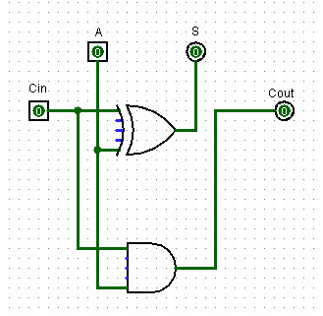a)

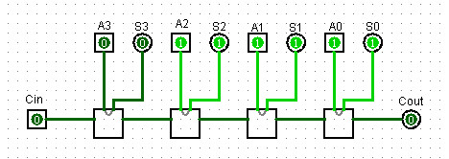

b)

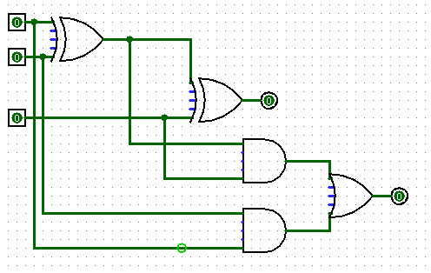

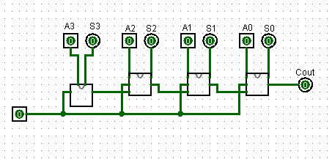

10.

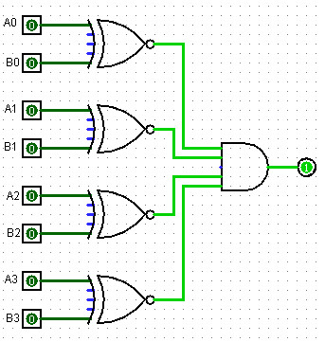

**Bài 11:**

|  |  |
| --- | --- |
| Excess-3  A B C D | Binary  w x y z |
| 0 0 1 1 | 0 0 0 0 |
| 0 1 0 0 | 0 0 0 1 |
| 0 1 0 1 | 0 0 1 0 |
| 0 1 1 0 | 0 0 1 1 |
| 0 1 1 1 | 0 1 0 0 |
| 1 0 0 0 | 0 1 0 1 |
| 1 0 0 1 | 0 1 1 0 |
| 1 0 1 0 | 0 1 1 1 |
| 1 0 1 0 | 1 0 0 0 |
| 1 1 0 0 | 1 0 0 1 |

w = AB + ACD

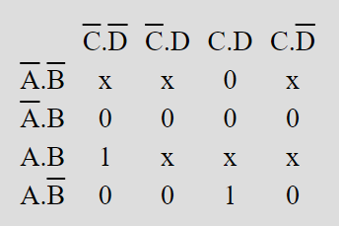

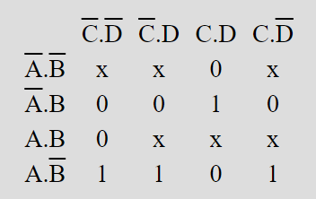

z = BCD + B’C’ + B’D’

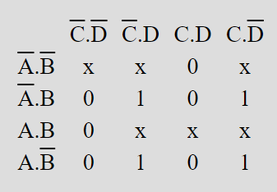

y = C’D + CD’

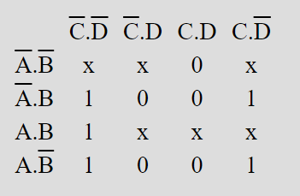

z = D’

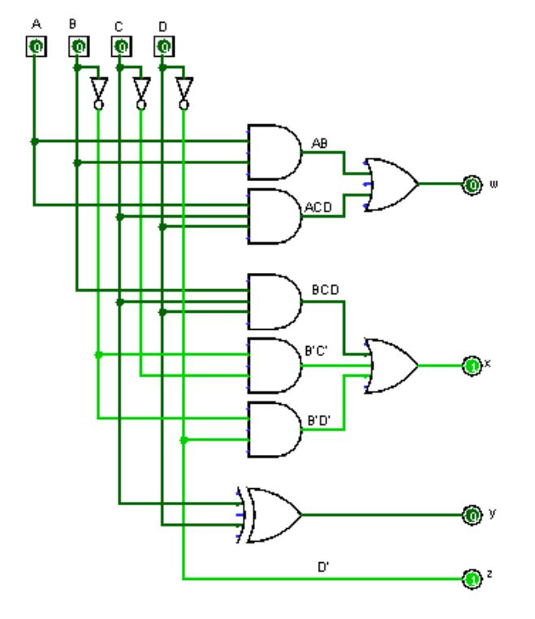

Bài 12: Vẽ sơ đồ logic của 2-to-4-line decoder sử dụng:

|  |  |  |  |  |  |  |  |  |  |  |  |  |  |  |  |  |  |  |  |  |  |  |  |  |  |  |  |  |  |  |  |  |  |  |  |  |  |  |  |  |  |
| --- | --- | --- | --- | --- | --- | --- | --- | --- | --- | --- | --- | --- | --- | --- | --- | --- | --- | --- | --- | --- | --- | --- | --- | --- | --- | --- | --- | --- | --- | --- | --- | --- | --- | --- | --- | --- | --- | --- | --- | --- | --- |
| |  |  |  |  |  |  |  |  |  |  |  |  |  |  |  |  |  |  |  |  |  |  |  |  |  |  |  |  |  |  |  |  |  |  |  |  |  |  |  |  |  | | --- | --- | --- | --- | --- | --- | --- | --- | --- | --- | --- | --- | --- | --- | --- | --- | --- | --- | --- | --- | --- | --- | --- | --- | --- | --- | --- | --- | --- | --- | --- | --- | --- | --- | --- | --- | --- | --- | --- | --- | --- | | |  |  |  |  |  |  |  |  | | --- | --- | --- | --- | --- | --- | --- | --- | | E |  | A | B | Y0 | Y1 | Y2 | Y3 | | 1 |  | 0 | 0 | 1 | 0 | 0 | 0 | | 1 |  | 0 | 1 | 0 | 1 | 0 | 0 | | 1 |  | 1 | 0 | 0 | 0 | 1 | 0 | | 1 |  | 1 | 1 | 0 | 0 | 0 | 1 | | |

Yo = EA’B’

Y1  = EA’B

Y2  = EAB’

Y3  = EAB

1. 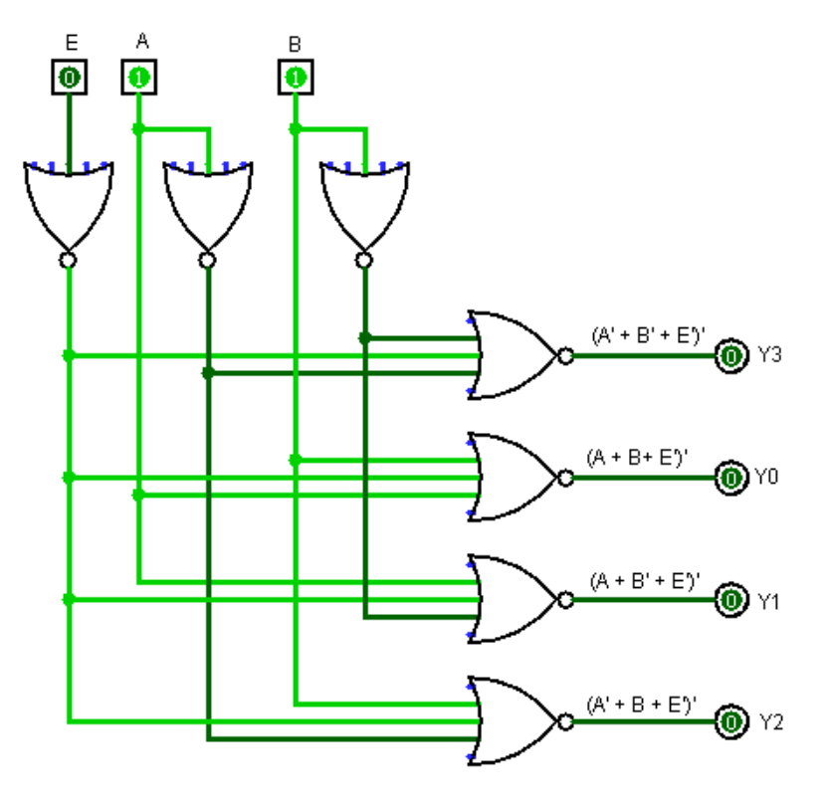chỉ cổng NOR
2. Chỉ cổng NAND

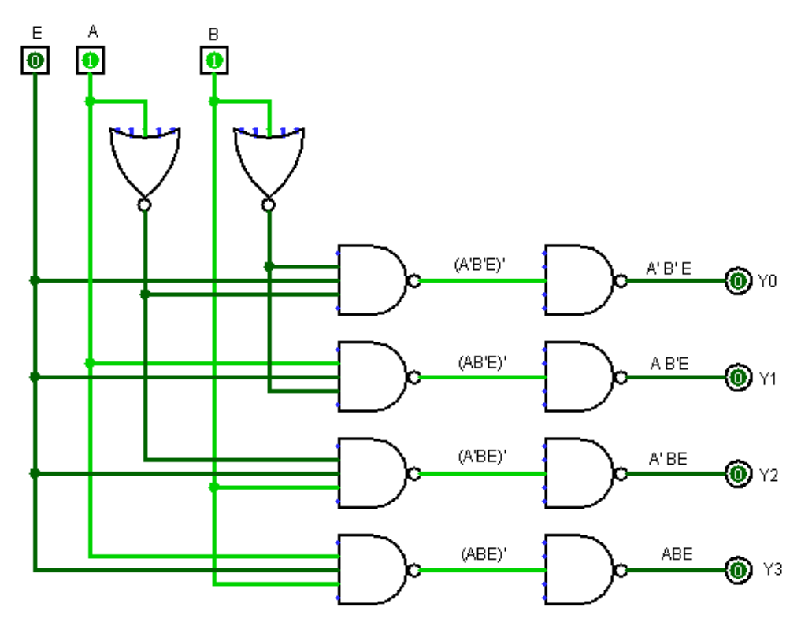

**13.** Thiết kế một decoder BCD sang số thập phân bằng cách sử dụng các tổ hợp mã BCD(không được sử dụng dưới dạng BCD thì không cần quan tâm).

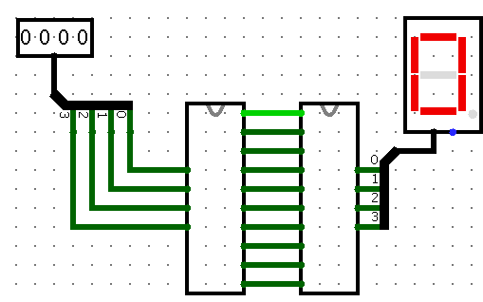 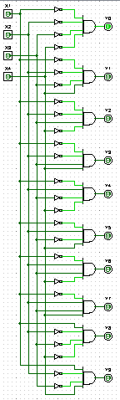 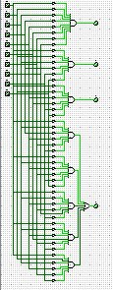

**14.** Xây dựng một 4-to-16-line decoder với năm 2-to-4-line decoder với enable(E).

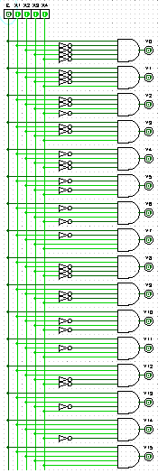

**Bài 15:**

**Bài 16:**

**a.**

**b.**

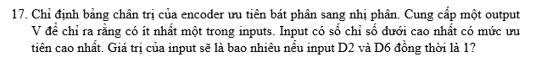

|  |  |  |  |  |  |  |  |  |  |  |  |
| --- | --- | --- | --- | --- | --- | --- | --- | --- | --- | --- | --- |
| **D0** | **D1** | **D2** | **D3** | **D4** | **D5** | **D6** | **D7** | **X** | **Y** | **Z** | **V** |
| 0 | 0 | 0 | 0 | 0 | 0 | 0 | 0 | X | X | X | 0 |
| 1 | 0 | 0 | 0 | 0 | 0 | 0 | 0 | 0 | 0 | 0 | 1 |
| X | 1 | 0 | 0 | 0 | 0 | 0 | 0 | 0 | 0 | 1 | 1 |
| X | X | 1 | 0 | 0 | 0 | 0 | 0 | 0 | 1 | 0 | 1 |
| X | X | X | 1 | 0 | 0 | 0 | 0 | 0 | 1 | 1 | 1 |
| X | X | X | X | 1 | 0 | 0 | 0 | 1 | 0 | 0 | 1 |
| X | X | X | X | X | 1 | 0 | 0 | 1 | 0 | 1 | 1 |
| X | X | X | X | X | X | 1 | 0 | 1 | 1 | 0 | 1 |
| X | X | X | X | X | X | X | 1 | 1 | 1 | 1 | 1 |

Nếu input D1 và D6 đồng thời là 1

Output:

|  |  |  |  |
| --- | --- | --- | --- |
| **X** | **Y** | **Z** | **V** |
| 1 | 1 | 0 | 1 |



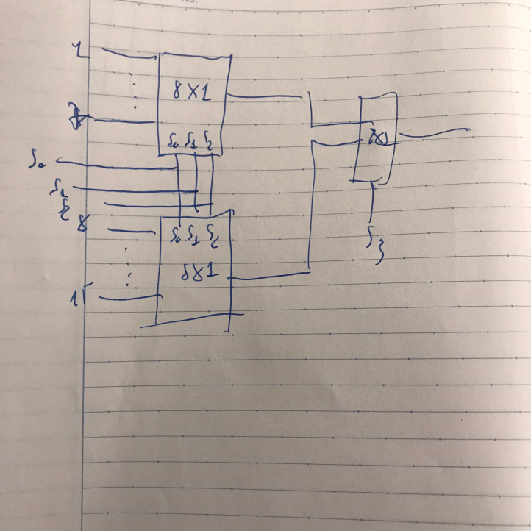

1. **Thực hiện chức năng Boolean sau với multiplexer:**
2. F (a, b, c, d) = ∑(0, 2, 5, 8, 10, 14)
3. F (A, B, C, D) = π(2,6,11)

* **Giải:**

Chuyển về SOP

1. F (a, b, c, d) = ∑(0, 2, 5, 8, 10, 14)

|  |  |  |  |  |  |  |
| --- | --- | --- | --- | --- | --- | --- |
| **A** | **B** | **C** | **D** | **F** |  |  |
| 0 | 0 | 0 | 0 | 1 | F=D’ | 0 |
| 0 | 0 | 0 | 1 | 0 |
| 0 | 0 | 1 | 0 | 1 | F=D’ | 1 |
| 0 | 0 | 1 | 1 | 0 |
| 0 | 1 | 0 | 0 | 0 | F=D | 2 |
| 0 | 1 | 0 | 1 | 1 |
| 0 | 1 | 1 | 0 | 0 | F=0 | 3 |
| 0 | 1 | 1 | 1 | 0 |
| 1 | 0 | 0 | 0 | 1 | F=D’ | 4 |
| 1 | 0 | 0 | 1 | 0 |
| 1 | 0 | 1 | 0 | 1 | F=D’ | 5 |
| 1 | 0 | 1 | 1 | 0 |
| 1 | 1 | 0 | 0 | 0 | F=0 | 6 |
| 1 | 1 | 0 | 1 | 0 |
| 1 | 1 | 1 | 0 | 1 | F=D’ | 7 |
| 1 | 1 | 1 | 1 | 0 |

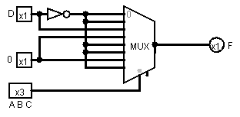

1. F (A, B, C, D) = π(2,6,11)

= (A’+B’+C+D’).(A’+B+C+D’).(A+B’+C+D)

* F’ = ABC’D + AB’C’D + A’BC’D’ = ∑(13, 9, 4)
* F(A, B, C, D) = ∑(0, 1, 2, 3, 5, 6, 7, 8, 10, 11, 12, 14, 15)

|  |  |  |  |  |  |  |
| --- | --- | --- | --- | --- | --- | --- |
| **A** | **B** | **C** | **D** | **F** |  |  |
| 0 | 0 | 0 | 0 | 1 | F=1 | 0 |
| 0 | 0 | 0 | 1 | 1 |
| 0 | 0 | 1 | 0 | 1 | F=1 | 1 |
| 0 | 0 | 1 | 1 | 1 |
| 0 | 1 | 0 | 0 | 0 | F=D | 2 |
| 0 | 1 | 0 | 1 | 1 |
| 0 | 1 | 1 | 0 | 1 | F=1 | 3 |
| 0 | 1 | 1 | 1 | 1 |
| 1 | 0 | 0 | 0 | 1 | F=D’ | 4 |
| 1 | 0 | 0 | 1 | 0 |
| 1 | 0 | 1 | 0 | 1 | F=1 | 5 |
| 1 | 0 | 1 | 1 | 1 |
| 1 | 1 | 0 | 0 | 1 | F=D’ | 6 |
| 1 | 1 | 0 | 1 | 0 |
| 1 | 1 | 1 | 0 | 1 | F=1 | 7 |
| 1 | 1 | 1 | 1 | 1 |

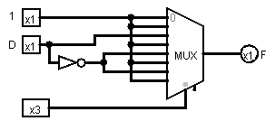

1. **Thực hiện một full adder với hai 4x1 multiplexers:**

|  |  |  |  |  |  |  |
| --- | --- | --- | --- | --- | --- | --- |
| **Đầu vào** | | | **Đầu ra** | |  |  |
| **X** | **Y** | **Z** | **S** | **C** |  |  |
| 0 | 0 | 0 | 0 | 0 | S=Z  C=0 | 0 |
| 0 | 0 | 1 | 1 | 0 |
| 0 | 1 | 0 | 1 | 0 | S=Z’  C=Z | 1 |
| 0 | 1 | 1 | 0 | 1 |
| 1 | 0 | 0 | 1 | 0 | S=Z’  C=Z | 2 |
| 1 | 0 | 1 | 0 | 1 |
| 1 | 1 | 0 | 0 | 1 | S=Z  C=1 | 3 |
| 1 | 1 | 1 | 1 | 1 |

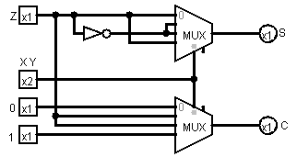

1. **Một multiplexers 8 x 1 có inputs A, B và C được kết nối với Selection inputs S₂, S₁ và S0. Các đầu vào dữ liệu I0 thông qua I7 như sau:**
2. I1=I2=I7=0; I3=I5=1; I0=I4=D; và I6=D’
3. I1=I2=0; I3=I7=1; I5=I4=D; và I6=I0=D’

* **Giải:**

1. I1=I2=I7=0; I3=I5=1; I0=I4=D; và I6=D’

|  |  |  |  |  |  |  |
| --- | --- | --- | --- | --- | --- | --- |
| **Đầu vào** | | | | **Đầu ra** |  |  |
| **A** | **B** | **C** | **D** | **I** |  |  |
| 0 | 0 | 0 | 0 | 0 | I0=D | 0 |
| 0 | 0 | 0 | 1 | 1 |
| 0 | 0 | 1 | 0 | 0 | I1=0 | 1 |
| 0 | 0 | 1 | 1 | 0 |
| 0 | 1 | 0 | 0 | 0 | I2=0 | 2 |
| 0 | 1 | 0 | 1 | 0 |
| 0 | 1 | 1 | 0 | 1 | I3=1 | 3 |
| 0 | 1 | 1 | 1 | 1 |
| 1 | 0 | 0 | 0 | 0 | I4=D | 4 |
| 1 | 0 | 0 | 1 | 1 |
| 1 | 0 | 1 | 0 | 1 | I5=1 | 5 |
| 1 | 0 | 1 | 1 | 1 |
| 1 | 1 | 0 | 0 | 1 | I6=D’ | 6 |
| 1 | 1 | 0 | 1 | 0 |
| 1 | 1 | 1 | 0 | 0 | I7=0 | 7 |
| 1 | 1 | 1 | 1 | 0 |

* F = ∑(1, 6, 7, 9, 10, 11, 12)

|  |  |  |  |  |
| --- | --- | --- | --- | --- |
| **AB CD** | **00** | **01** | **11** | **10** |
| **00** | 0 | 1 | 0 | 0 |
| **01** | 0 | 0 | 1 | 1 |
| **11** | 1 | 0 | 0 | 0 |
| **10** | 0 | 1 | 1 | 1 |

* EPls = 4

F = ABC’D’ + B’C’D + A’BC + AB’C

1. I1=I2=0; I3=I7=1; I5=I4=D; và I6=I0=D’

|  |  |  |  |  |  |  |
| --- | --- | --- | --- | --- | --- | --- |
| **Đầu vào** | | | | **Đầu ra** |  |  |
| **A** | **B** | **C** | **D** | **I** |  |  |
| 0 | 0 | 0 | 0 | 1 | I0=D’ | 0 |
| 0 | 0 | 0 | 1 | 0 |
| 0 | 0 | 1 | 0 | 0 | I1=0 | 1 |
| 0 | 0 | 1 | 1 | 0 |
| 0 | 1 | 0 | 0 | 0 | I2=0 | 2 |
| 0 | 1 | 0 | 1 | 0 |
| 0 | 1 | 1 | 0 | 1 | I3=1 | 3 |
| 0 | 1 | 1 | 1 | 1 |
| 1 | 0 | 0 | 0 | 0 | I4=D | 4 |
| 1 | 0 | 0 | 1 | 1 |
| 1 | 0 | 1 | 0 | 0 | I5=D | 5 |
| 1 | 0 | 1 | 1 | 1 |
| 1 | 1 | 0 | 0 | 1 | I6=D’ | 6 |
| 1 | 1 | 0 | 1 | 0 |
| 1 | 1 | 1 | 0 | 1 | I7=1 | 7 |
| 1 | 1 | 1 | 1 | 1 |

* F = ∑(0, 6, 7, 9, 11, 12 , 14, 15)

|  |  |  |  |  |
| --- | --- | --- | --- | --- |
| **AB CD** | **00** | **01** | **11** | **10** |
| **00** | 1 | 0 | 0 | 0 |
| **01** | 0 | 0 | 1 | 1 |
| **11** | 1 | 0 | 1 | 1 |
| **10** | 0 | 1 | 1 | 0 |

* EPls = 4

F = A’B’C’D’ + ABD’ + AB’D + BC

22.Thực hiện chức năng boolean sau multiplexers 4 x 1 và cổng external.

(a) f₁ (a, b, c, d) =∑ (1, 3, 4, 11, 12, 13, 14, 15)

(b) f₂ (a, b, c, d) =∑ (1, 2, 5, 7, 8, 10, 11, 13, 15)

Kết nối đầu vào A và B với selections. Các yêu cầu đầu vào cho bốn dữ liệu

Các dòng sẽ là một hàm của các biến C và D. Các giá trị được bằng cách biểu thị F như

một hàm của C và D cho mỗi bốn trường hợp khi AB= 00,01, 10 và 11. các hàm này

có thể được thực hiện với external gates.

AB=10

F=1

AB=11

F=CD=(C’+D’)

AB=01

F=C’D’

AB=00

F=D

|  |  |  |  |  |
| --- | --- | --- | --- | --- |
| A | B | C | D | F |
| 0 | 0 | 0 | 0 | 0 |
| 0 | 0 | 0 | 1 | 1 |
| 0 | 0 | 1 | 0 | 0 |
| 0 | 0 | 1 | 1 | 1 |
| 0 | 1 | 0 | 0 | 1 |
| 0 | 1 | 0 | 1 | 0 |
| 0 | 1 | 1 | 0 | 0 |
| 0 | 1 | 1 | 1 | 0 |
| 1 | 0 | 0 | 0 | 0 |
| 1 | 0 | 0 | 1 | 0 |
| 1 | 0 | 1 | 0 | 0 |
| 1 | 0 | 1 | 1 | 1 |
| 1 | 1 | 0 | 0 | 1 |
| 1 | 1 | 0 | 1 | 1 |
| 1 | 1 | 1 | 0 | 1 |
| 1 | 1 | 1 | 1 | 1 |

(b) f₂ (a, b, c, d) =∑ (1, 2, 5, 7, 8, 10, 11, 13, 15)

AB=10

F=D

AB=01

F=D

AB=11

F=C’D’+CD’+CD=D’+C

AB=00

F=C xor D

|  |  |  |  |  |
| --- | --- | --- | --- | --- |
| A | B | C | D | F |
| 0 | 0 | 0 | 0 | 0 |
| 0 | 0 | 0 | 1 | 1 |
| 0 | 0 | 1 | 0 | 1 |
| 0 | 0 | 1 | 1 | 0 |
| 0 | 1 | 0 | 0 | 0 |
| 0 | 1 | 0 | 1 | 1 |
| 0 | 1 | 1 | 0 | 0 |
| 0 | 1 | 1 | 1 | 1 |
| 1 | 0 | 0 | 0 | 1 |
| 1 | 0 | 0 | 1 | 0 |
| 1 | 0 | 1 | 0 | 1 |
| 1 | 0 | 1 | 1 | 1 |
| 1 | 1 | 0 | 0 | 0 |
| 1 | 1 | 0 | 1 | 1 |
| 1 | 1 | 1 | 0 | 0 |
| 1 | 1 | 1 | 1 | 1 |